Random Scenario Generator
by Tarjei Aasen
Last updated: 080112
For quite some time now I have been writing scenarios for this game and I’ve been looking for a way to generate different scenarios to be used in campaigns or for one-off games. This particular generator was made by looking at the one presented by Gav Thorpe in WD 292 and tinkering around with it until it was more to my liking. The goal was to fix as many of the obvious problems (Meeting Engagement, the objectives and the events, primarily) as possible while adding more variety and my own twist to it.

Choose armies
Both players agree a maximum points value for the battle and choose their armies from the appropriate list.

Vanguard and Rearguard
At this stage they may also detach one or more units to form a Vanguard or a Rearguard. This can become important depending on the Engagement type the armies fight. Depending on the size of the game being played, there are maximum sizes to the Vanguard and Rearguard, and a minimum number of units that must be kept in the Main Force (see table 1 below). War Machines and Immobile items (see 1.2 below) can never be part of a Vanguard or Rearguard. Large targets may not be included in the Vanguard and the General must be in the Main force. An army does not have to have a Vanguard or Rearguard, but it is usually advisable.
Characters mounted on monsters or chariots count as units, other characters do not.
Note: Players should roll for spells before allocating units to Vanguards and Rear guards. High Elves should also determine who the General is at this point.

Table 1.1 – Vanguard and Rear guard
Army size in pts | Max Vanguard | Min Main Force | Max Rearguard
Up to 999 | 1 | 2 | 1
1,000 to 1,999 | 2 | 3 | 2
2,000 to 2,999 | 3 | 4 | 3
3,000 to 3,999 | 4 | 5 | 4
Each additional 1,000 | +1 | +1 | +1

Determine Engagement type
There are three possible types of engagement which categorise the various ways in which the armies might meet on the field of battle. Roll a D6 to find out what type of engagement the armies are fighting:

Table 2.1 - Engagement type
1-2 Pitched battle - The two armies manoeuvre for a battlefield suitable to their liking, then make camp for the night. The following day, the armies are deployed and battle commences! Pitched battles are the most straightforward type of engagement.
3-4 Meeting engagement - The two armies close with each other quickly, and must deploy from their column of march to fight. A meeting engagement favours a faster army, or one with a substantial Vanguard.
5-6 Assault - One army attacks the other in a defended position. Each player rolls a D6; the highest scoring player decides whether to be the attacker or defender. In case of a tie, randomly determine who will be the attacker and who the defender. An assault gives the attacker advantages in deployment, but an enemy Rearguard can cause trouble.
Note: The Wood Elves’ special rules for deployment and Victory points apply to all Pitched Battle scenarios and when defending in an Assault.

Determine Terrain
Divide the table into squares of approximately 2’ x 2’. Determine which terrain table to use by rolling a D6. 1-2: Lowlands, 3-4: Highlands, 5-6: Coastal.
Table 3.1 - Terrain tables
2D6 | Lowlands | Highlands | Coastal
2 | River or lake | River or lake | Inlet of the sea
3 | Marsh | Rocky peak | River or lake
4 | Village | Boulders | Marsh
5 | Field boundaries | Crag | Scrub
6 | Hill | Wood | Hill
7 | 1-3: Hill, 4-6: Wood | 1-3: Hill, 4-6: Scrub | 1-3: Hill, 4-6: Ruins
8 | Wood | Hill | Ruins
9 | Scrub | Ruins | Small building
10 | Ruins | Scrub | Village
11 | Crag | Ancient wall | Ruins
12 | Large building | Small building | Boulders
After determining the table each player in turns selects one square and rolls on the terrain table to generate a piece of terrain which is placed in the centre of the square. On a roll of 7, roll a further D6. Then roll the Scatter and Artillery dice. If a Misfire is rolled the terrain piece is removed. Otherwise the piece is moved in the direction of the Scatter dice a distance in inches equal to the roll on the Artillery dice. If a Hit is rolled the number on the Artillery dice is halved and the little arrow on the Hit-symbol is used. A further roll of the Scatter dice can be used to determine the orientation of the terrain piece, if necessary.

Determine Deployment
Roll a D6 and consult the appropriate table to determine the deployment zones for the battle.
Table 4.1 - Pitched battle deployment
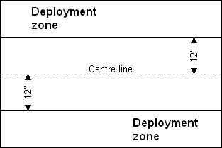  1 – 2: Pitched A | 3 – 4: Pitched B
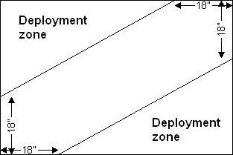  5: Pitched C | 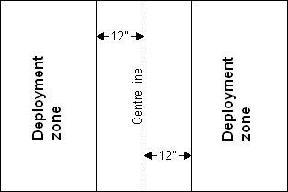  6: Pitched D

Table 4.2 - Meeting engagement deployment
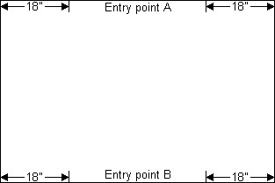  1 – 2: Meeting A | 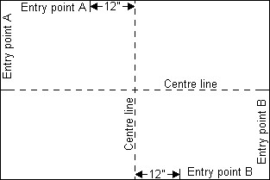  3 – 4: Meeting B
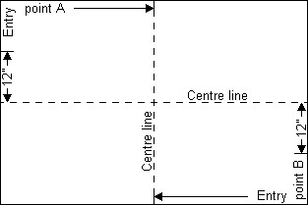  5: Meeting C | 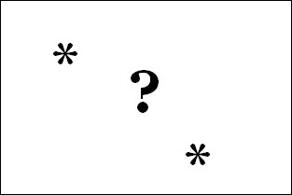  6: Meeting D

Table 4.3 – Assault deployment
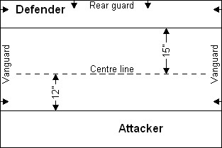  1 – 2: Assault A | 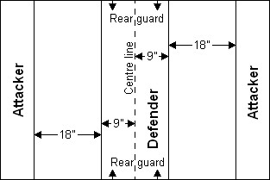  3 – 4: Assault B
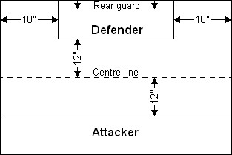  5: Assault C | 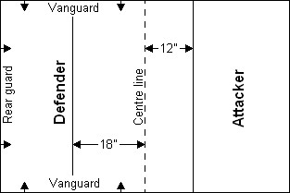  6: Assault D

For all Pitched Battle and Meeting Engagement scenarios both players then roll a D6 each, with the player with the fastest Vanguard (i.e. the fastest unit in your Vanguard is faster than the fastest unit in his Vanguard) adding +1 to his roll. The highest roller chooses which deployment zone he’ll have (re-roll ties).
In Pitched B, Pitched C, Meeting B and Meeting C the first player chooses any table corner to deploy around and the other player gets the opposite corner.
In Meeting D the first player chooses a 24” stretch of the table edge to be Entry point A. The other player then chooses a 24” stretch of the table to be Entry point B. Entry point B must be at least 48” from Entry point A.
In Assault A and Assault C the defender chooses which long table edge to defend. In Assault D the defender chooses which short table edge to defend.

Determine Missions
Each player will have two missions, each of which has one goal. Each goal fulfilled at the end of the battle is worth a number of Victory points equal to 10% of your opponent's army size. I.e. if you are fighting against a 2,000 pt army each of your two missions are worth 200 VPs.

Objective markers
Each player must supply two objective markers, between 20 mm and 40 mm in either direction. After determining deployment zones players take it in turn to place their objective markers, one at a time. One marker must be at least 10” from the table edge, while the other must be at least 15” from the table edge. Objective markers must be at least 10” away from other objective markers already on the table. Markers should be placed where you think you can defend them and the enemy will have trouble getting to.
After the markers have been placed the players roll the scatter and artillery dice for each of their own objectives in turn and move the markers the rolled number of dice in the indicated direction. If a Hit is rolled without a Misfire the number on the Artillery dice is halved and the little arrow on the Hit symbol is used. If a Misfire is rolled the opponent may move the objective marker up to 10” in any direction. Objective markers may not be placed in impassable terrain, and if they end up scattering into such terrain move them out by the shortest route. In an objective marker scatters on top of another marker shuffle them slightly so that they are no longer touching.
Objective markers do not block lines of sight and do not hinder movement.
Each player then takes it in turn to roll 2D6 for each of his missions and looks the results up on table 8 below to see what they are.

Table 5.1 - Missions
2D6 | Pitched battle | Meeting eng. | Assault attacker | Assault defender
2-3 | Witch Hunt | Cleanse | Trophy | Escort
4 | Hold the line | Dig In | Witch Hunt | Witch Hunt
5 | Cleanse | Opportunity | Cleanse | Revenge
6 | Dig In | Revenge | Rescue | Hold the Line
7 | Opportunity | Advance | Breakthrough | Dig In
8 | Advance | Rescue | Advance | Cleanse
9 | Revenge | Trophy | Scatter them | Trophy
10 | Breakthrough | Witch Hunt | Revenge | Opportunity
11-12 | Trophy | Escort | Opportunity | Rescue

Terms
Scoring units - A Scoring unit is a non-fleeing unit with a Unit Strength of 10 or more. Swarms and Empire Detachments are never Scoring units.
Eliminated – A unit or character is eliminated if it is destroyed, has fled the table or is fleeing at the end of the battle.
Holding objective markers – An objective marker is held at the end of the battle if you have a Scoring unit within 4” of the centre of the objective while the opponent does not. Each objective marker may only be held once, if a dice roll indicates that a player would have to hold the same marker twice, re-roll it.
Unique missions - You can only have one of each unique mission. Re-roll any duplicates.

The missions
Advance - Hold any one enemy objective marker at the end of the battle.
Breakthrough (unique) - You must have a certain number of Scoring units completely inside the enemy Deployment Zone at the end of the battle. The number needed is one unit per 1,000 points in your army, rounding fractions up. I.e. in a 2,000 pt army you need 2 units, in a 2,500 pt army you need 3.
Cleanse - Hold any two table quarters at the end of the battle.
Dig In - Hold any one own objective marker at the end of the battle.
Escort - A travelling dignitary has joined the army and must be protected at all cost. Nominate two of your Scoring units; the opponent decides which of those two the dignitary has joined. The dignitary should be mounted on the same base size as the unit (substitute any model with the correct base size if you have no appropriate miniature) and has the same Movement as the unit. He has 2’s for all other stats, except that he has only 1 Attack and no save. He is subject to instability or crumbling if the unit is.
The dignitary may be placed in any rank of the unit and may not leave it during the battle. He may use the “Look out, Sir!” rule, but follows no other character rules. The mission is fulfilled if the dignitary is not eliminated.
If you have less than two Scoring units the dignitary is not used and you automatically fail to fulfil this goal.
Hold the Line (unique) - The enemy has no Scoring units completely inside your Deployment Zone at the end of the battle.
Opportunity - Hold one random objective marker at the end of the battle. Number the markers 1 to 4 and roll a D6 to determine which to hold. On a 5 the opponent decides which marker you’ll have to hold and on a 6 you pick which marker to hold.
Rescue - You must rescue any enemy objective marker and keep it at the end of the battle. A Scoring unit can pick up an objective marker if it is in contact with it at the end of its Movement phase and is not in contact with enemy units. Remove the marker and make a note of which unit now carries it. The objective can now be captured by enemy units in the same manner as standards, though only Scoring units may carry it. If a unit ends up with a Rescue objective it cannot carry it immediately drops it, the owning player placing it anywhere in contact with the unit. Dropped objectives can be picked up by Scoring units from either side if they are in contact with it and no enemy units at the end of their Movement phase. Enemy units may not pick up objectives that have not been moved yet. Once you pick up one marker, you may not pick up the other (unless you have two Rescue missions).
Revenge (unique) - Eliminate the enemy General.
Scatter them (unique) – The enemy must have no Scoring units completely inside his own deployment zone at the end of the battle.
Trophy (unique) - Hold more standards than the enemy does (your own plus those captured by the enemy) at the end of the battle. Battle Standards count double for this purpose.
Notes: Bretonnian Peasants’ standards do not count for this purpose.
Witch Hunt (unique) - Eliminate more wizards than the enemy does. Level 3-4 wizards count double for this purpose. Re-roll if the enemy has no wizards.
Should none of the missions rolled use objective markers the markers may be removed.

Determine Special circumstances
Each player rolls a D6; the results are added together and looked up on table 9 - Minor Events, below. In addition, if a double is rolled the double rolled is also looked up on table 10 - Major Events table, which follows after.

Table 6.1 - Minor Events
- No Minor Event
- Weak magic - All spells cast suffer a –1 modifier to their casting roll. However, spells will not Miscast, even if a double 1 is rolled.
- Perfectly clear – All missile weapons that use BS may re-roll 1s rolled to hit.
- Good omens - All units have a +1 modifier to their Ld when taking Panic, Fear and Terror tests (after other modifiers, such as using the General’s Ld) up to a maximum value of 10.
- Gremlins in the machinery / Salamander bellyache - All missile weapons that normally automatically hit must roll to hit using their BS and applying all regular modifiers for range, skirmishers, and so on. Breath weapons and magic missiles are not affected.
- No Minor Event
- Boggy ground - All cavalry units, chariots and monsters are at –1 to their Movement value for the duration of the battle (i.e. –2 to any charge or march moves). Models which normally have a Move of 7 and are now reduced to 6 will flee and pursue 2D6” rather than 3D6. Fly moves and ethereal creatures are not affected.
Steam Tanks are reduced to moving 2” per Steam point rather than the normal 3”.
- Bad omens - All units have a –1 modifier to their Ld when taking Panic, Fear and Terror tests (after other modifiers, such as using the General’s Ld).
- Dusk or dawn – Roll a D6; on a 1 it will be night for the first turn of the game, on a roll of 2-5 there is no special effect, while on a roll of 6 it will be night for turn 6 and later (if the game lasts that long). Roll an Artillery dice at the start of each game turn when it is night and multiply the result by 4. This is the maximum range all units can see. Units may not charge, shoot or cast spells at units they can not see. Night does not affect Ethereal creatures or spells that do not require a line of sight.
- Strong magic - All spells receive a +1 modifier to their casting roll. However, any double rolled (except a double 6) will cause a Miscast.
- No Minor Event

Table 6.2 - Major Events
- Rampant madness - At the start of the battle each character in each player’s army will fight a round of combat against the unit he is with, his mount (if it is a chariot or monster) or against himself, at the owning player’s choice. The model is always assumed to use a hand weapon. The characters do not count as charging, no combat results are worked out, no blows are struck back and no panic tests are taken. Mounts do not attack.
- Hot and dry - All units that charge more than their normal Movement value are at –1 to hit for the first round of combat.
- Strong high winds - Roll an Artillery dice at the start of each game turn. For the entire turn all flying moves are reduced by the number rolled. If a Misfire is rolled flyers may not fly that turn and are reduced to using their ground movement.
- Rainstorm - All shooting that relies on BS to hit are at –1 to hit in addition to other modifiers. All other missile weapons must roll 3+ on a D6 to be able to fire.
In addition, at the start of each game turn both players roll a D6; the lower roller must nominate one of his units to be hit by lightning, taking that many S5 hits. I.e. if the lower player rolled a 2 then he must select one of his units that will take 2 S5 hits. In case of a tie both players must nominate a unit. The nominated unit must be either a Large Target, a unit of Ogre-sized creatures or the unit with the best armour save. Lightning count as Lightning damage.
- Chilling cold - All models who are charged and who are not already engaged in combat are at –1 to hit for the first turn of combat.
- Plague - Before the battle each player must nominate one of his units to carry the plague. At the start of each own shooting phase the unit and all other units within 2” of it take D6 S3 hits with no armour save. Single characters take a single hit instead of D6.

Deploy armies
Deployment is done differently depending on the type of battle being played.
Reinforcements – In some cases parts of the army may be held back and arrive later. You must note down which units are being used as reinforcements before deployment begins, as well as which table edge each unit will arrive from, if given a choice. Units may arrive from different table edges if you wish.
The description will say in which turn reinforcements may start to arrive. Roll a D6 for each unit at the start of this turn; units arrive on a 4+ and move onto the table from the designated table edge, counting as returning after having pursued an enemy unit off the table. Units that fail to arrive will show up on a 3+ at the start of the next turn, and so on.
In any battle where a player cannot physically fit his entire army into his Deployment zone any units that won’t fit will be reinforcements and may arrive from turn 3 from any table edge inside the player’s Deployment zone.

Pitched Battle
The players roll a D6 each, with the one who did not get to choose deployment zones adding +1 to his dice roll. The higher roller decides which player starts deploying units. Players alternate placing one unit at a time in the following order: Vanguard, Main Force and lastly Rear Guard. Once you have finished deploying one part of the army, do not wait for your opponent to do the same; simply continue with the next part.
All War Machines are deployed at the same time, though they may be placed in different parts of the battlefield. Characters on their own in the same part of the army are placed all at the same time as a single placement choice and may not deploy in units, characters in units deploy when the unit deploys.
Scouts may be deployed using their special rules once both armies have been deployed.
Notes: In any set up either player may designate any number of units in his Rear guard as reinforcements. Reinforcements may arrive from any table edge inside the owning player’s deployment zone and may start to arrive from turn 1.

Meeting Engagement
The players roll a D6 each, with the one who did not get to choose entry points adding +1 to his dice roll. The higher roller decides which player starts deploying units (it should be noted that the player who starts deploying units will get to decide which player moves first).
Units in Meeting engagement are not deployed in the normal manner. Instead the first player moves all of the units in his Vanguard onto the table from his entry point, each making a single normal move (they may not march, etc.), and then his opponent does the same. After all Vanguard units have moved onto the table the first player then moves his entire Main force onto the table in the same manner, though one or more units may be held back and deployed with the Rear Guard. Each unit held back lets one Vanguard unit make a second normal move (a Vanguard unit may not be given a third move in this manner and Flyers may only ever make a single move). The second player then does the same. Units making these deployment moves cannot use them to charge. Any sort of test taken at the beginning of the turn that can affect the movement of the unit (Stupidity, Animosity, Unruly, etc.) are not taken and ignored until the game actually begins.
All immobile items, such as a Cauldron of Blood, Casket of Souls or Field Trebuchet, may choose to make a single move at the base speed of their crew will then have to spend a complete game turn after they have finished moving to properly set up or consecrate the item. Until it is set up none of the special rules for the item apply (no Ward save for Witch Elves, no Light of Death, etc.), though missile fire is randomised between the item and the crew as normal. If the item has no crew, such as an Effigy of Gork, it cannot do this.
Units with random movement counts as having rolled 6 if their movement is 2D6 and 9 if their movement is 3D6.
Rear guard units and Main force units held back move onto the table at the start of a player’s first turn, counting as returning after having pursued an enemy unit off the table. They make normal moves, not Deployment moves.
Special deployment rules (Scouts, Ambush, ‘It came from below’, Underground advance, etc) can not be used in Meeting Engagements, except for Hidden troops, such as Assassins and Fanatics.

Assault
The defender deploys his Vanguard and Main Force in his deployment zone. The attacker then deploys his entire army in his deployment zone(s). Scouts may be deployed once both armies have been deployed. The defender’s Rear guard move onto the table at the start of his first turn, counting as having returned after pursuing an enemy unit off the table.
Notes: In Assault A and Assault D the attacker may send any number of units in his Vanguard to arrive as reinforcements. In Assault A, units may arrive from either short table edge, and in Assault D units may arrive from either long table edge. Reinforcements may start to arrive from turn 2.

Determine game length and first turn
Roll a D6 on table 8.1 below to determine game length

Table 8.1 - Game length
Pitched battle | Meeting eng. | Assault | Length
1 – 3 | 1 – 3 | 1 – 3 | 6 turns
4 |  | 4 – 5 | 7 turns
5 – 6 | 4 – 6 | 6 | Random game length

Random game length – Roll a D6 after both players have finished their fifth turn. On a 1-2 the game ends. On a 3+ play a sixth turn and then roll another D6. After the sixth turn the game ends on a 1-3. On a 4+ play a seventh and last turn.

Pitched battle - Both players roll a D6, the one who finished deploying first adding +1 to his roll. The higher roller decides whether to go first or second.
Meeting engagement - The player who started moving his units onto the table decides who has the first turn.
Assault - The defender decides who has the first turn.

Fight the battle
You know how this goes: 1-2-3 get ’em!

Determine the winner
As mentioned in step 5, each goal fulfilled at the end of the battle is worth a number of Victory points equal to 10% of your opponent's army size. I.e. if you are fighting against a 2,000 pt army each of your two missions are worth 200 VPs. When the difference in Victory points has been determined cross-difference this with the army size to determine the degree of Victory.
Remember that a 2,000 pt army is still a 2,000 pt army even if only 1,998 pts were used.
- You receive a number of Victory points equal to the points value of each enemy unit either destroyed, fleeing or having fled the table.
Each character is counted as a separate unit for this purpose, and characters mounted on monsters or chariots are also counted separately from their mount.
- You also receive Victory points for each enemy unit reduced to half its original number or models or below, and Independent models (characters, chariots and monsters) reduced to half their starting number of wounds or below. Score Victory points equal to half the unit’s points value (rounded up).
- Enemy General slain, fleeing or having fled the table: 50 Victory points per full 1000 pts in the enemy army (i.e. 0 for armies of less than 1000 pts, 50 pts for armies of 1000 or more but less than 2000 pts, and so on). This is in addition to Victory points for being a destroyed unit.
- Divide the table into four quarters. Each table quarter that contains at least one of your Scoring units (see 4.2 above) and no enemy Scoring units: 50 Victory points per full 1000 pts in the enemy army (see above).
Units partly inside more than one quarter counts as being in whichever quarter they are mostly in.
- Each enemy unit Standard or Battle Standard captured at the end of the battle: 50 Victory points per full 1000 pts in the enemy army (see above).

Table 10.1 - Victory points
 | 500 -  999 | 1,000 – 1,499 | 1,500 – 1,999 | 2,000 – 2,499 | 2,500 – 2,999 | 3,000 – 3,499 | 3,500 – 3,999 | 4,000 –  4,499
0 – 149 | D | D | D | D | D | D | D | D
150 - 299 | MV | MV | D | D | D | D | D | D
300 - 449 | MV | MV | MV | D | D | D | D | D
450 - 599 | SV | SV | MV | MV | MV | D | D | D
600 - 749 | SV | SV | MV | MV | MV | MV | MV | D
750 - 899 | M | SV | SV | MV | MV | MV | MV | MV
900 – 1,199 | M | M | SV | SV | MV | MV | MV | MV
1,200 – 1,499 | M | M | SV | SV | SV | MV | MV | MV
1,500 – 1,799 | M | M | M | SV | SV | SV | SV | MV
1,800 – 2,099 | M | M | M | M | SV | SV | SV | SV
2,100 – 2,499 | M | M | M | M | M | SV | SV | SV
2,500 – 2,999 | M | M | M | M | M | M | SV | SV
3,000 – 3,499 | M | M | M | M | M | M | M | SV
3,500+ | M | M | M | M | M | M | M | M

