TROPHY

Overview: This one is for glory! You must attempt to hold as many standards at the end of the battle as possible.

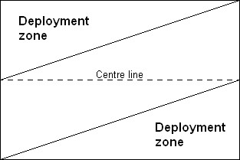

DEPLOYMENT
- Both players roll a die, the player who scores highest may select any of the four corners of the table to deploy around and deploys his first unit in that zone (see map). The other player gets the diagonally opposite corner.
- The other player then deploys one of his units in his own deployment zone. After that, taking it in turns, each player deploys one unit at a time, in the zones pictured on the map.
- All the war machines in an army are deployed at the same time, though they can be deployed in different parts of the deployment zone.
- The characters in an army are all deployed simultaneously as the last unit the player deploys. Each of them may of course be deployed in a different part of the deployment zone and they may be deployed within units.
- Units with the Scouts special rule are not deployed with the rest of the army. Instead they are placed on the table after all units in both armies have been deployed, as described in the rules for Scouts.

Who goes first? Both players roll a dice, the player who finished their deployment first (not counting scouts) may add +1 to their dice roll. The player who scores highest may choose whether to go first or second (re-roll ties).
Length of game: The game lasts for six turns.
Special rules: There are no additional special rules.
Victory conditions: Use the standard procedure for calculating Victory Points, with the following alterations.
Capturing enemy standards, apart from the Battle Standard, do not gain Victory Points in the normal manner. Instead, the player that controls the most standards at the end of the battle (his own plus those captured from the enemy) gains +500 Victory points. Obviously standards in fleeing units don’t count. Neither do Bretonnian Peasants’ standards, but Battle Standards count double.

